To: Professor Martinez

From: Murtaza Amjad

Date: 2/19/2024

Subject Lab 1 Technical Memo

The lab goal was to design a mechanism in which the allows you to display your student ID # in Morse code. The parts used in the lab were the Arduino UNO R3, 3-color RGB light, reed switch, button, wires, USB power cable. Every time I pressed the button the light would light up depending on what the number of my ID was being represented by Morse code. If I put some type of magnet near the reed switch it would go back to the first number in my ID.

Some of the problems I ran into were like having the wires on correctly/ in the right positions and linking those positions to the IDE. This was fundamental because it allowed me to create a deeper understanding of how to use a programming language to interact with a hardware. Giving me skills that are very valuable when it comes to the computer science industry.

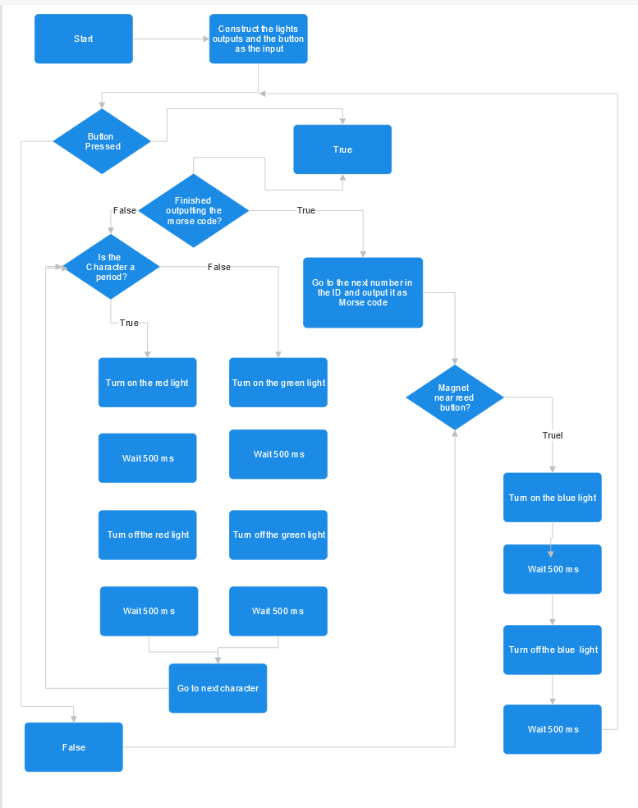

Figure 1. Program Flowchart

The flowchart quickly shows you how the program runs and what happens at each step of the way. If you follow the chart, you can see it describes what is happening in the video. It helps give a step-by-step process on what's happening when certain things go into effect.

The result of the lab was a successful program that allows you to show your student ID number in Morse Code. It followed all the given criteria. The red light is for periods and the green light is for dashes. When the magnet gets close to the reed switch it will reset the program so that it starts from the beginning of the ID. This project can become more complex and advanced by adding more parts to the integration of the hardware with the software.

Appendix:

Sources-

Morse Code Link - <https://www.sckans.edu/~sireland/radio/code.html>

Code:   
  
//all my variables

int greenLed = 5;

int blueLed = 7;

int redLed = 6;

int reedbutton = 10;

int startbutton = 4;

int myID[] = {0,0,7,8,0,7,4,9};

int idx = 0;

const char* morseID[10] = {".----","..---","...--","....-",".....","-....","--...","---..","----.","-----"};

void setup() {

// all my setup code:

pinMode(redLed,OUTPUT);

pinMode(greenLed,OUTPUT);

pinMode(blueLed,OUTPUT);

pinMode(startbutton,INPUT_PULLUP);

pinMode(reedbutton,INPUT_PULLUP);

}

void loop() {

// main code:

//outputs red if it's a “.” and outputs a green if it's a “-”.

int press = digitalRead(startbutton);

if(press == LOW){

for(int i = 0; morseID[myID[idx]][i] != '\0'; i++) {

if(morseID[myID[idx]][i] == '.'){

digitalWrite(redLed,HIGH);

delay(500);

digitalWrite(redLed,LOW);

delay(500);

}

else{

digitalWrite(greenLed,HIGH);

delay(500);

digitalWrite(greenLed,LOW);

delay(500);

}

}

//increments to the next number

idx++;

if (idx >= sizeof(myID) / sizeof(myID[0])) {

idx = 0; //resets the index if it goes over the size of the array,

//just incase

}

}

//if it the reedbutton is hit then it resets to the first index of the student number

if (digitalRead(reedbutton) == LOW) {

idx = 0;

digitalWrite(blueLed,HIGH);

delay(500);

digitalWrite(blueLed,LOW);

}

}